1. Go to SE11
2. Select Data Type. Enter the name of table type as zxxxxinttab where XXXX is your empcode.

104329 in this example.

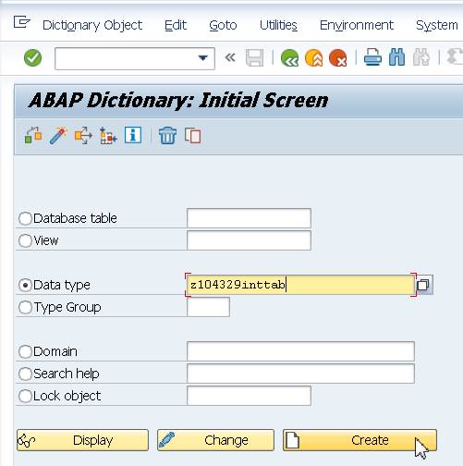

1. Select Table Type.

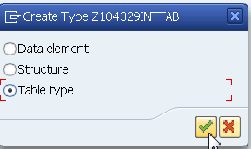

1. Select Pre Defined Data Type. Enter Data Type as INT1.
2. Save and Activate.

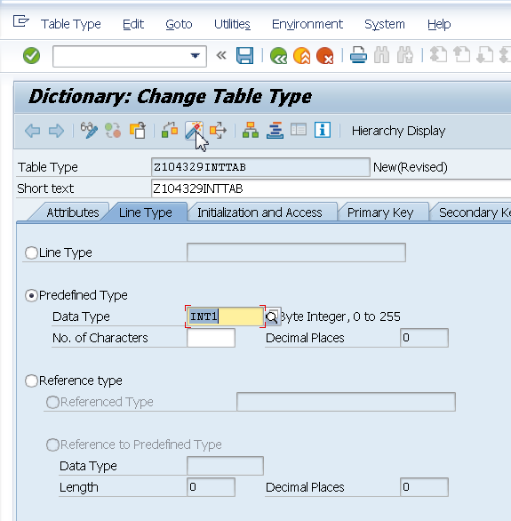

REPORT Z.  
*"DATA ITAB TYPE TABLE OF I.*  
DATA ITAB TYPE Z104329INTTAB.  
DATA WA TYPE I.  
  
WA = 10. APPEND WA TO ITAB.  
WA = 20. APPEND WA TO ITAB.  
WA = 30. APPEND WA TO ITAB.  
WA = 40. APPEND WA TO ITAB.  
WA = 50. APPEND WA TO ITAB.  
  
LOOP AT ITAB INTO WA.  
  WRITE:/ WA.  
ENDLOOP.